How to Hire a Biweekly Student

IRIS transaction ZHR_STUDENT_HIRE Student Hire E-Form
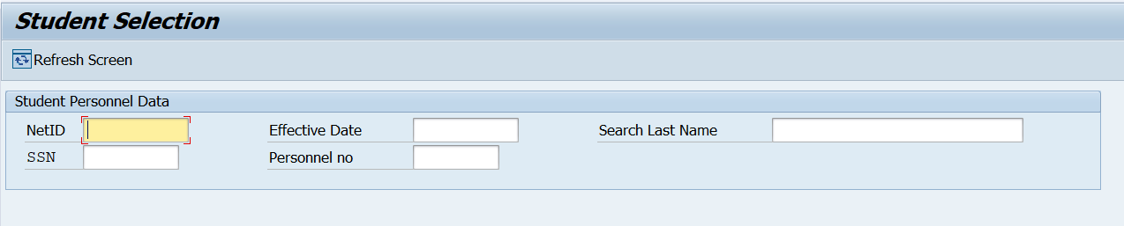
Enter the NetID or SSN of the student or the personnel number if a rehire.
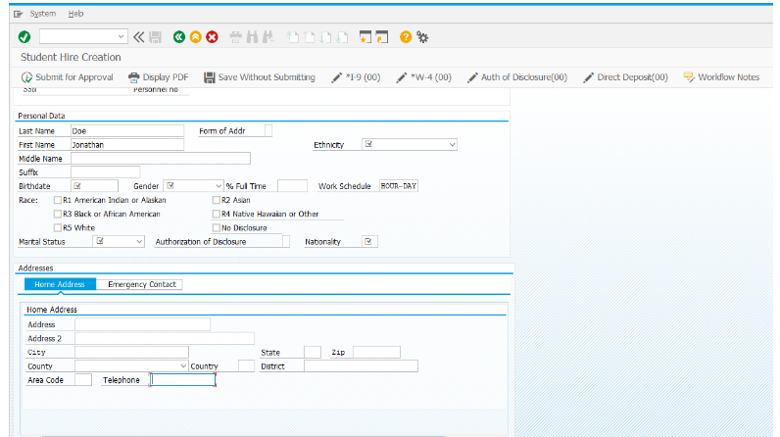
You will be presented with a screen to enter all the student information. You will also attach the W-4 and I-9 document with the ID’s used. Do not include emails or correspondence.
Verify that the hire date entered and the first day of employment on page 2 of the I9 are the same.
You have the option to attach the authorization of disclosure form however UTK no longer uses that form.
Add notes before you are ready to submit. If you save without submitting the notes will not be saved.

